
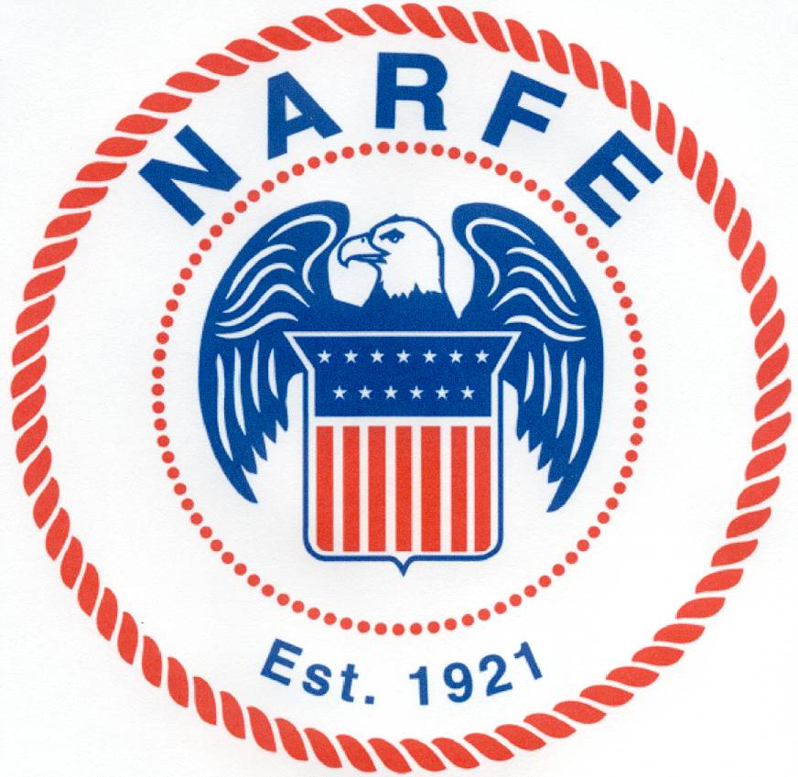
C
S
C
F
C
S
C
F
NARFE
CALIFORNIA STATE FEDERATION OF CHAPTERS

2007 State Convention
Costa Mesa, California
May 18-20, 2007
PURCHASE ORDER AND INVOICE FOR SOUVENIR PROGRAM BOOK ADVERTISEMENT

Advertiser/Chapter: __________________________________________________________ Date: __________________

Address: __________________________________________________________________________________________
Street City State ZIP

Contact Person: ___________________________________ Phone: _____________ Email: ________________________

Ad Size: Full Page Half Page Quarter Page Business Card

Ad Color: Black/White Full Color (Full color ads are available for the first time.)
Full payment, check only, for this advertisement order should be enclosed with the ad, but MUST be received by the deadline date. Payment enclosed: $_____________
Make checks payable to: 2007 CSFC Convention Committee.

Amount enclosed: $________________.

If you do desire a display table please list your representative below. Advertisers who purchase a full page color ad are entitled to one exhibit table for display purposes at no additional charge.

Representative: ____________________________________ Phone: ________________ Email: __________________________
Advertisement Rates

Full color advertisements, obviously, must be furnished in color (if b/w is ordered, we can do a gray scale) and all ads should be “camera ready.” Please furnish prints on the whitest and brightest paper you can get and mail in large envelopes braced with cardboard inserts so the copies do not bend or crease. You may also send the ad on CD, 3½” floppy, or by email, preferably in Publisher format. Deadline for receipt of advertisements and checks is
FEBRUARY 18, 2007. Please mail all advertising materials and payments to:
BOB DAVIDSON
1538 QUAIL RIDGE ROAD
ESCONDIDO, CA 92027-4719

For questions concerning advertisements, call Bob Davidson, (760) 432-0081 or email at
oldbobdavidson@myexcel.com.
NARFE
CALIFORNIA STATE FEDERATION OF CHAPTERS

(Year) State Convention
(Location)
(Date)
C
S
C
F

PURCHASE ORDER AND INVOICE FOR PROGRAM BOOK PROMOTIONS
NARFE INDIVIDUAL AND CHAPTER ONLY

Chapter Name & Number/Individual’s Name __________________________________ Date: __________

Address: _____________________________________________________________________________
(Street) (City) (State) (ZIP)

Contact Person: _____________________________ Phone: _____________ Email: ________________

Promotion/Advertisement Size: Full Page Half Page Quarter Page Business Card

Color: The price for all promotions for NARFE individuals and NARFE Chapters is the same for color and black/white. The promotion will be printed as submitted.

Full payment, check only, for this promotion order should be enclosed with the promo copy, but MUST be received by the deadline date of (Date).

Payment enclosed: $_____________ Make checks payable to: “(Date) Convention Host Committee”

Type | Size (In inches) | Member/Chapter Price
Full Page | 4 ½ w X 7½ h | (Price)
Half Page | 4 ½ w X 3 ¾ h | (Price)
Quarter Page | 4½ w X 1⅞ h | (Price)
Business Card | 3½ w X 2 h | (Price)

All promos should be “camera ready”, which means the exact size listed above and the content the way you wish it printed in the booklet. You may send the copy on CD/DVD, 3½” floppy, or by email [preferably in Publisher or PDF format]. If you mail a printed copy, please furnish the print on the whitest and brightest paper you can get and mail in a large envelope braced with cardboard inserts so the copy does not bend or crease [prints must be scanned and creases sometimes show].

Deadline for receipt of promotions, booster lists, and checks is (Date).

Please mail all promotional materials and booster lists, with payments, to:
(insert the Program Committee Chair’s name and address)

Note: For questions concerning promotions and help in constructing a good looking promotion/advertisement with photos, call (insert Program Committee Chair’s name, telephone and email) at least two weeks before the deadline date.

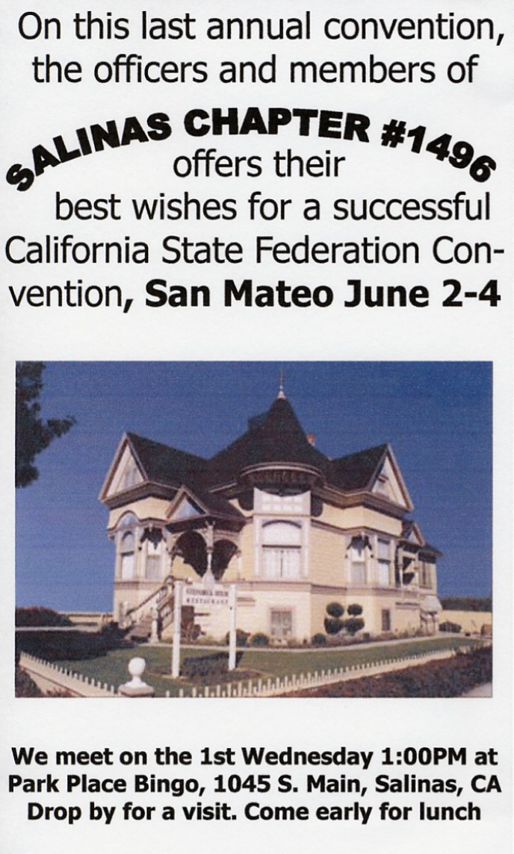
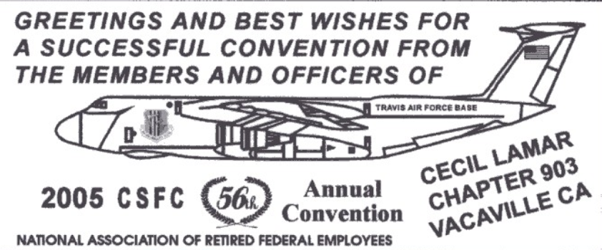
C
S
C
F
C
S
C
F
C
S
C
F
C
S
C
F
C
S
C
F
SIZES FOR SOUVENIR PROGRAM BOOK ADVERTISING

The boxes below are the sizes available.
FULL PAGE
4½ w X 7½ h
HALF PAGE
4½ w X 3 ¾ h
QUARTER PAGE
4½ w X 1_{7/8} h
BUSINESS CARD
3½ w X 2 h
See the difference between COLOR and B/W in your ad. It’s worth the extra cost!
SIZES FOR SOUVENIR PROGRAM BOOK ADVERTISING

The boxes below are the sizes available.
FULL PAGE
4½ w X 7½ h
HALF PAGE
4½ w X 3 ¾ h
QUARTER PAGE
4½ w X 1_{7/8} h
BUSINESS CARD
3½ w X 2 h
See the difference between COLOR and B/W in your ad. It’s worth the extra cost!
SIZES FOR SOUVENIR PROGRAM BOOK ADVERTISING

The boxes below are the sizes available.
FULL PAGE
4½ w X 7½ h
HALF PAGE
4½ w X 3 ¾ h
QUARTER PAGE
4½ w X 1_{7/8} h
BUSINESS CARD
3½ w X 2 h
See the difference between COLOR and B/W in your ad. It’s worth the extra cost!
SIZES FOR SOUVENIR PROGRAM BOOK ADVERTISING

The boxes below are the sizes available.
FULL PAGE
4½ w X 7½ h
HALF PAGE
4½ w X 3 ¾ h
QUARTER PAGE
4½ w X 1_{7/8} h
BUSINESS CARD
3½ w X 2 h
See the difference between COLOR and B/W in your ad. It’s worth the extra cost!
SIZES FOR SOUVENIR PROGRAM BOOK ADVERTISING

The boxes below are the sizes available.
FULL PAGE
4½ w X 7½ h
HALF PAGE
4½ w X 3 ¾ h
QUARTER PAGE
4½ w X 1_{7/8} h
BUSINESS CARD
3½ w X 2 h
See the difference between COLOR and B/W in your ad. It’s worth the extra cost!
SIZES FOR SOUVENIR PROGRAM BOOK PROMOTIONS

The boxes below are the sizes available.

FULL PAGE
4½ w X 7½ h

HALF PAGE
4½ w X 3 ¾ h

QUARTER PAGE
4½ w X 1⅞ h

BUSINESS CARD
3½ w X 2 h

