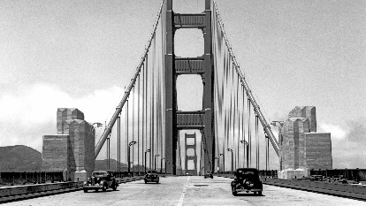

1 PHOTO

Text

**San Francisco Chapter 65**

*Chartered November 1951*

**Chapter Officers (optional)**

President: Name Here Vice President: Name Here

Secretary: Name Treasurer: Name Here

Agency Acronyms USPS – VA - etc